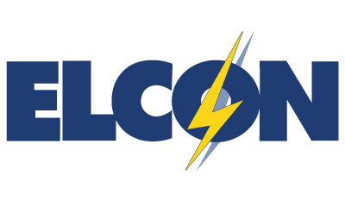
January 31, 2019
Contact: 202-682-1390

Statement of ELCON CEO Devin Hartman on the Extreme Cold Weather and Grid Reliability

The recent cold spell is another example that electricity markets can keep the lights on as the fuel mix evolves. Severe weather events do not justify prescriptive regulations to enhance fuel security. Such actions would raise costs unnecessarily to American families and businesses and, in particular, erode the global fuel cost advantage needed by manufacturers.

Grid reliability threats will continue to evolve, and industrial electricity consumers ask regulators and reliability authorities to remain prudent. Regulators should ensure reliability standards are cost-justified and that market prices accurately reflect supply and demand fundamentals. If so, consumers will have the flexibility to meet their reliability needs at least cost.

