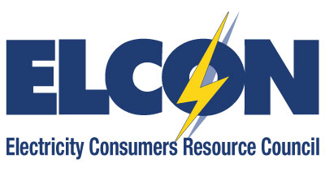

2020 Calendar
January 1 | New Year’s Day Holiday | July 4 | Independence Day
January 16 | ELCON Technical Committee Call | July 16 | FERC Open Meeting
January 20 | MLK Day | July 19-22 | NARUC Summer Policy Summit
January 23 | FERC Open Meeting | July TBD | NERC Trades Meeting
January 23 | NERC Trades Meeting | August 19-20 | NERC BOT/MRC Meeting
February 5-7 | NERC BOT/MRC Meetings | September 7 | Labor Day
February 9-12 | NARUC Winter Policy Summit | September 10 | ELCON Board/Technical  Committee Call
February 17 | Presidents Day | September 17 | FERC Open Meeting
February 20 | FERC Open Meeting | September 27 | Yom Kippur
February 27 | ELCON Annual Meeting Call | September 29-30 | ELCON Fall Workshop & Board/Member Meeting
March 19 | ELCON Technical Committee Call | October 12 | Columbus Day
March 19 | FERC Open Meeting | October 15 | FERC Open Meeting
April 10 | Good Friday | October 22 | ELCON Technical Committee Meeting
April 16 | Emancipation Day – Washington DC | October TBD | NERC Trades Meeting
April 16 | FERC Open Meeting | November 4-5 | NERC BOT/MRC Meetings
April 29-30 | ELCON Spring Workshop & Board/Member Meeting | November 8-11 | NARUC Annual Meeting
April TBD | NERC Trades Meeting | November 11 | Veterans Day
May 13-14 | NERC BOT/MRC Meetings | November 19 | FERC Open Meeting
May 21 | ELCON Technical Committee Call | November 26-27 | Thanksgiving
May 21 | FERC Open Meeting | December 3 | ELCON Technical Committee Call
May 25 | Memorial Day | December 17 | FERC Open Meeting
June 18 | FERC Open Meeting | December 24-25 | Christmas Eve & Christmas
June 25 | ELCON Board/Technical  Committee Call | December 31 | New Year’s Eve Day

